SUMMARY


Abstract:
In this Support Kit, we will show you how to create a model using the Datasheet Curve Modeler.
We have provided you with a lab guide, sample reference plot image and Designer project.
The lab will guide you through the process of VHDL-AMS model creation by creating a free hand model over a datasheet image using the Datasheet Curve Modeler.
Estimated time to complete: 15 – 30 minutes
Version Information: X-ENTP VX.2.13

DETAILS
Creating a Model Using Datasheet Curve Modeler:
Download Datasheet_Curve_Modeler.zip to your Desktop
- Unzip the file to your Desktop
- Open ReferencePlot.png found in the Datasheet_Curve_Modeler folder
- Type AMS into the Search Bar, open your version of AMS flow (This lab is using Xpedition AMS VX.2.13)
- Once open, select File > Open > Project
- Navigate to DCM.prj under the Datasheet_Curve_Modeler folder
- Simulation > Model and Symbol Wizard
- Under the Select Source tab, select Datasheet then click Next
- Under the Select/Create Model tab, select Datasheet Curves in the dropdown menu
- Click Launch to open the Datasheet Curve Modeler
- Start the image capture tool from File > Capture Image
  - An alternative way is to go to File > Open> Existing Image and navigate to ReferencePlot.png found in the Datasheet_Curve_Modeler folder (image is a .png type)
- Click Capture in the Image Capture window
- Drag capture tool over open datasheet image
- Resize capture tool to enclose image
- Click Save As
- Enter DMS_res_plot and save to “Desktop\Datasheet_Curve_Modeler” as a jpeg image
- Open Data Ranges from Edit > Set Data Range
- Enter range and type for x-axis data, in this case x-min = -50 and x-max = 100.
- Select Linear for datatype
- Enter range and type for y-axis data, in this case y-min = 100 and y-max = 1100
- Select Linear for datatype
- Confirm form entries
- Select Bound Box Mode from Edit > Set Bounding Box
- Confirm bounding box instructions
- Define graph bounding box
- Click on upper-most (xmin, ymax) value
- Click on origin (xmin, ymin) value
- Click on right-most (xmax, ymin) value
  - Blue box appears bounding the graph area
- Select Add Data Points mode from Edit < Add Data Points
  - Digitize waveform.
    - Click left-to-right along waveform to place data points
    - Data points must be within blue data boundary
    - Data table is automatically filled-in with data point coordinates
    - Points must be monotonically increasing along x-axis
  - Edit data points
    - Click and drag data points.
    - Edit values in the data table.
    - Add data points by right clicking on one datapoint and selecting “Add datapoint” in the menu
NOTE: If you have more than one curve, go to Configure >Number of Curves > Curve Number. You will go from left to right along the waveform but now there will be multiple datapoints every time you click on the curve.
NOTE: Restriction of x-axis or y-axis movement of datapoints can be implemented through Configure > Lock Datapoint X or Y Movement

- File > Create Model and Save the Data File
- Choose model type
  - For this example, select the resistor as a function of voltage under the Passive tab
- Confirm the Save data to file window
  - Respond to generator prompts
    - Click OK to open Save As form
    - Enter text res_vs_volt and save to “Desktop\Designer_Curve_Modler\DMS\hml”
    - Click Save to save text file and generate model/symbol
    - Click OK to close model confirmation form
  - Close the Datasheet Curve
- Verify Model Details in the Wizard
  - VHDL-AMS file name
    - RES_VS_VOLT.vhd
  - Model Entity
    - Defines model parameters and ports, select RES_VS_VOLT
  - Model Architecture
    - Describes device behavior, select IDEAL
  - Click Next
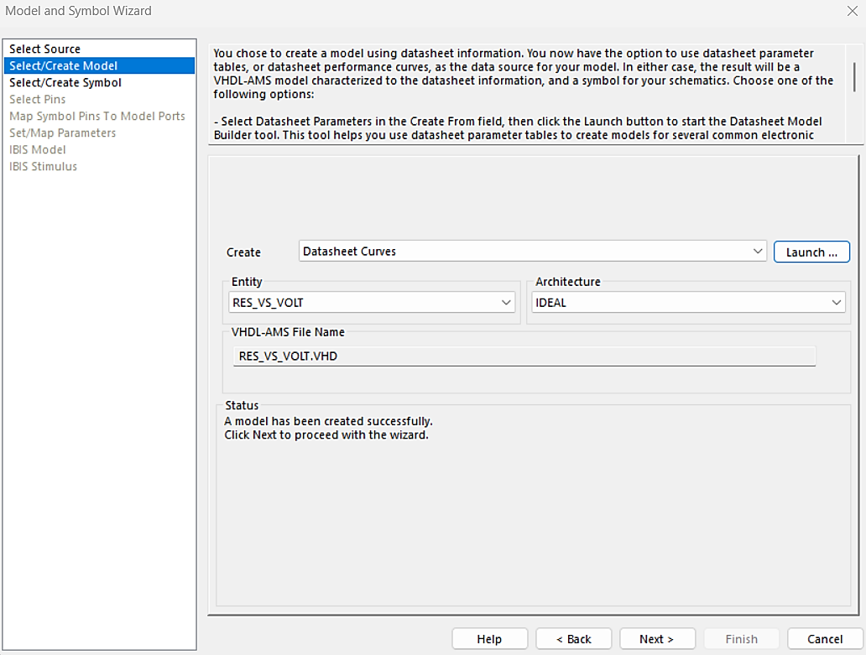
- Select/Create Symbol Window
  - Review model source code
  - Select the source for symbol graphics
    - Default: Use the symbol selected in the Datasheet tool
  - Click Next
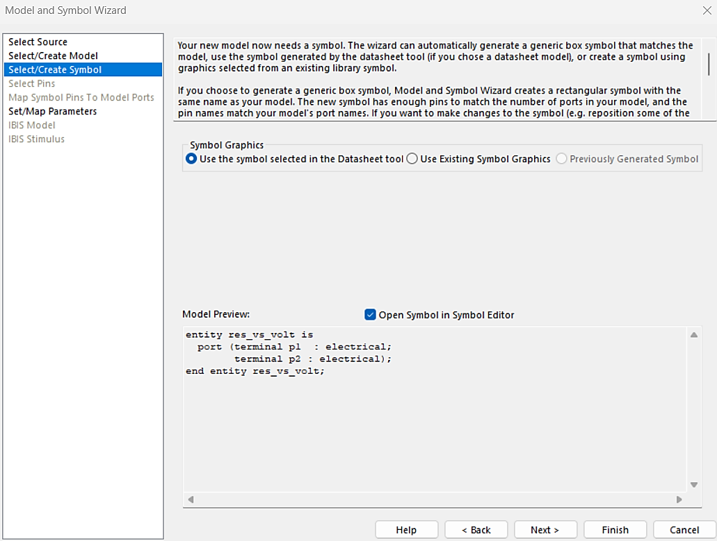
- Verify Set/Map Parameters Details
  - Review the parameter table.
    - If needed, change information in the Value column
    - Table may be grey if no parameters in the model can be changed
    - In this example, the table will be blank
  - Click Finish
- Choose Model Library
  - Select Local Library to save the model into. Other options include:
    - Local Project
    - Default shared library
    - User defined libraries
  - Click OK to save the model and close the Model and Symbol Wizard
    - Model is now available in the Simulation > Search/Place Symbol or DataBook library browsers
- A window with the symbol will pop up, this can be closed to return to the schematic.
- Delete the placeholder resistor
- Open Simulation > Search/Place Symbol
- Click the + sign on (Current Project)
- Click the + sign on (DMS)
- Select and place res_vs_volt
- Close Search/Place Symbol
- Place res_vs_volt symbol where placeholder resistor used to be
- Select Simulation > Simulate
- Click on the Multi-Run tab
  - Select “Sweep Values” under Multi-Run Tab
  - Check “DC Sweep”
  - Click Parameter Edit
    - Parameter: Select value seen (should match ID of voltage source)
    - Sweep Type: Increment
    - Sweep Start: -50
    - Sweep Stop: 100
    - Sweep Increment: 1
    - Click Ok
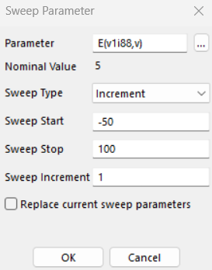
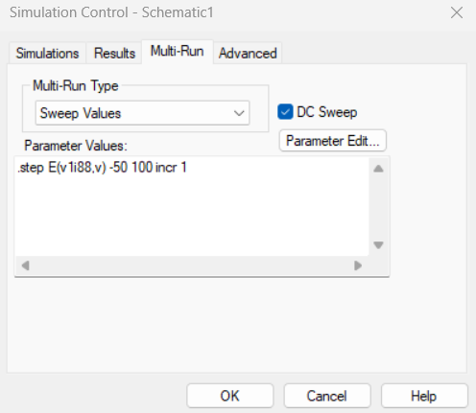
- Under the Results tab, select “All Waveforms” in the drop-down menu under DC Waveforms. This will give the waveform for the new resistor that was just placed.
- Under the Simulations tab, neither Time-Domain or Frequency Analysis should be enabled
- Click Ok
- Simulation will perform 151 runs; progress can be seen in the bottom left of the Xpedition tool.
- Waveform Analyzer will open once simulation is complete.
- Click the + next to y1<yournumber> in the Waveform List
- Double click the wave res
- The waveform will match the one taken in the Datasheet Curve Modeler
